AI Assisted coding(Lab-8.1)

M.Sanjana
HT Num: 2303A52292
Batch : 43

Task 1 — Password Strength Validator

Create a Python function password_strength(password) to classify passwords as Weak,

Medium, or Strong.

A strong password must be at least 8 characters long and include uppercase, lowercase,

digit, and special character with no spaces.

A medium password meets length and any 2–3 conditions. 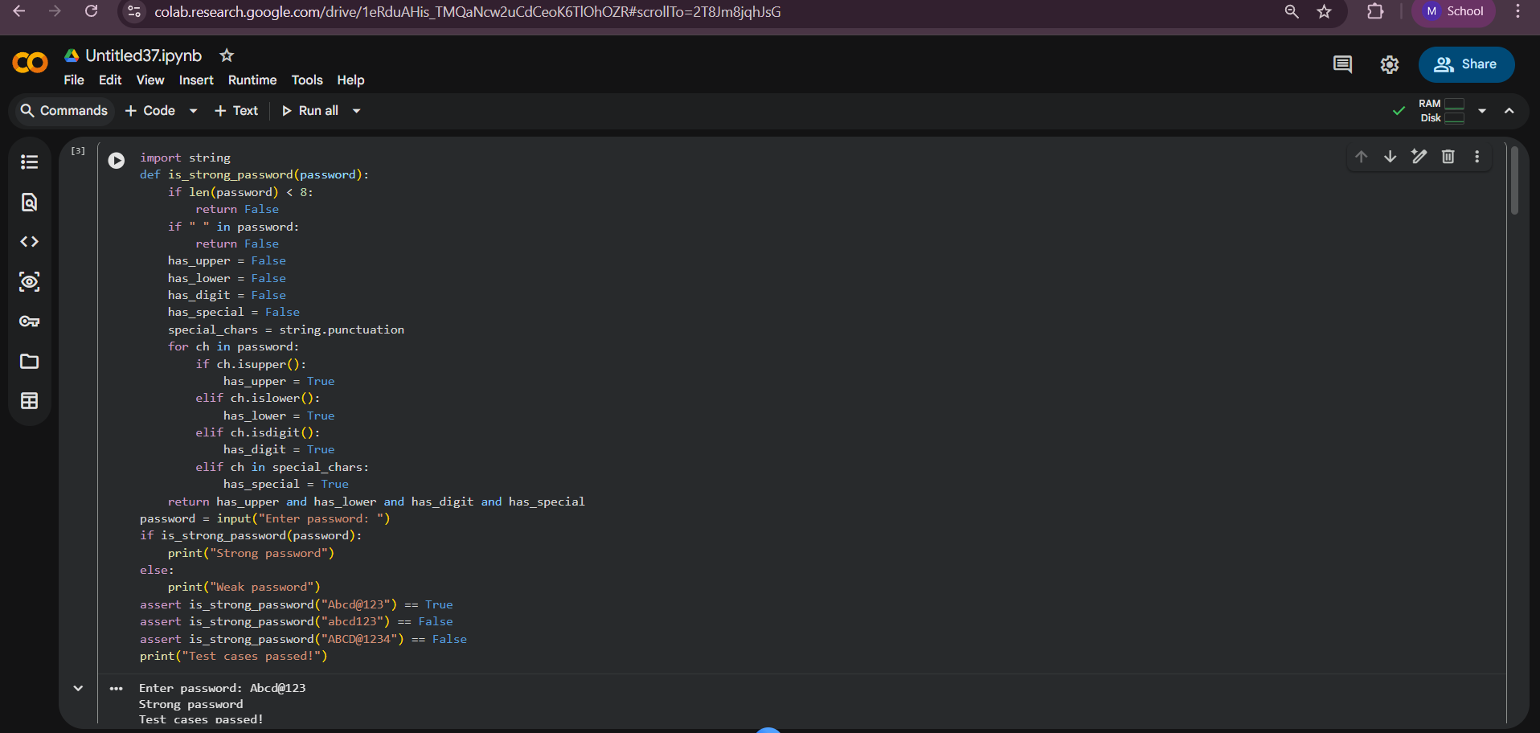
Task-2:
Write a Python function classify_number(n) using loops to classify a number as Positive, Negative, or Zero.
Handle invalid inputs like strings and None by returning "Invalid Input".
Include boundary conditions such as -1, 0, and 1.
Generate at least 3 assert test cases.
Also display output using user input.
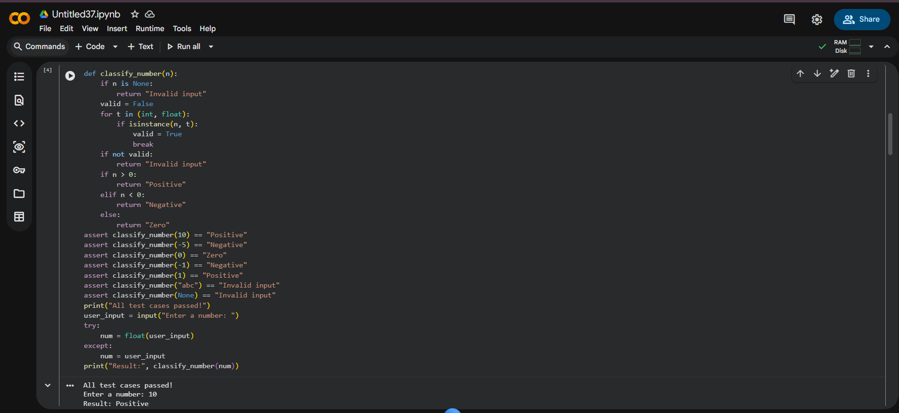
Task-3:
Create a Python function is_anagram(str1, str2) to check if two strings are anagrams.
Ignore case, spaces, and punctuation while comparing.
Handle edge cases like empty strings and identical words.
Generate at least 3 assert test cases.Show input and output examples.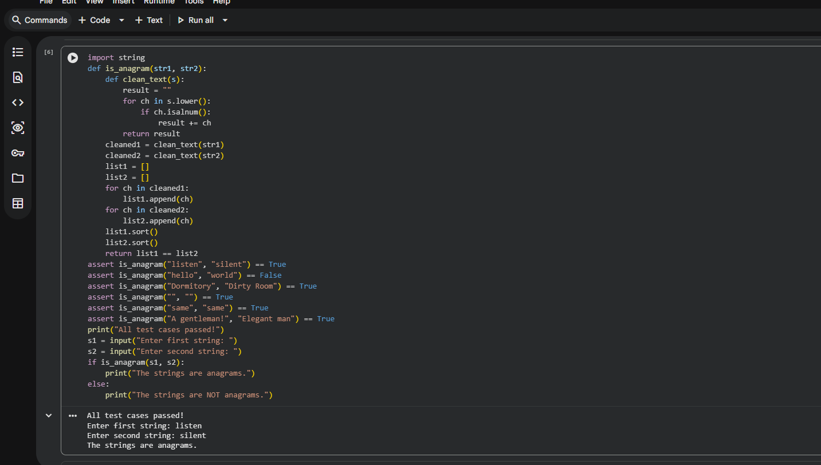
Task 4 — Inventory Class

Design a Python class Inventory to manage stock items.
Include methods: add_item(name, quantity), remove_item(name, quantity), and get_stock(name).
Ensure stock never becomes negative and handle missing items.
Generate at least 3 assert-based test cases.
Demonstrate functionality with sample input and output.
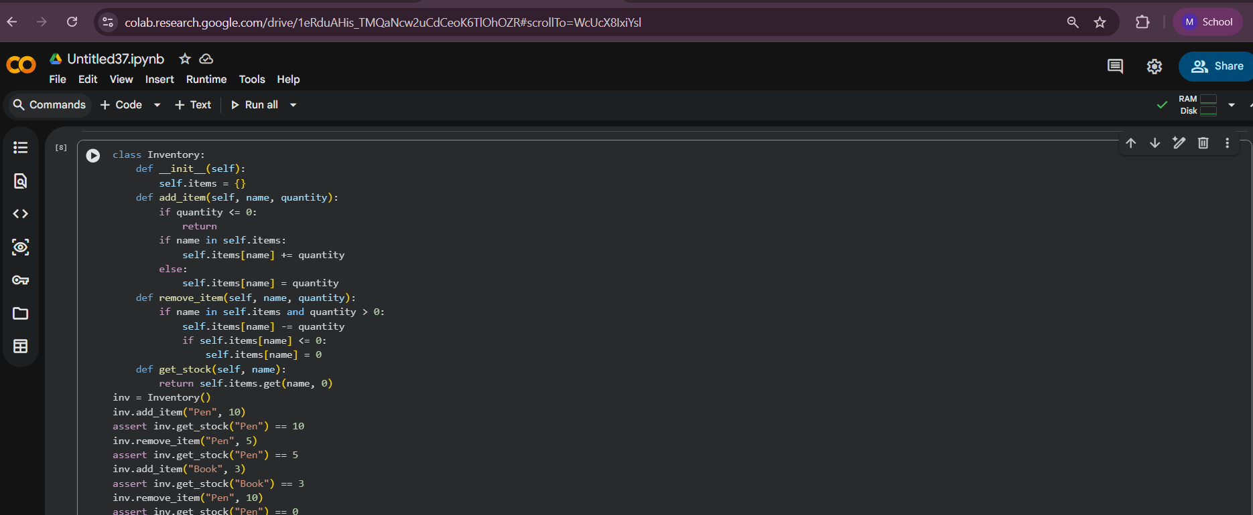

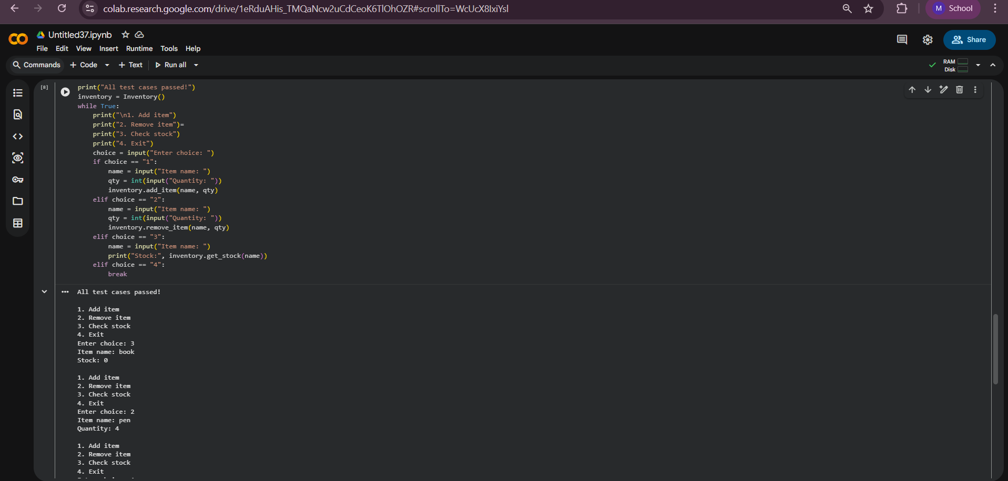
Task 5 — Date Validation & Formatting

Write a Python function validate_and_format_date(date_str) to validate dates in "MM/DD/YYYY" format.
Convert valid dates to "YYYY-MM-DD" and return "Invalid Date" for wrong inputs.
Handle invalid dates, formats, and leap year cases.
Generate at least 3 assert test cases.
Display results using user input.
